**SCALAR QUANTITIES:**

1. Scalar quantities do not need direction for their description.
2. Scalar quantities are comparable only when they have the same physical dimensions.
3. Two or more than two scalar quantities measured in the same system of units are equal if they have the same magnitude and sign.
4. Scalar quantities are denoted by letters in ordinary type.
5. Scalar quantities are added, subtracted, multiplied or divided by the simple rules of algebra.

**VECTOR QUANTITIES:**

1. Physical quantities having both magnitude and direction with appropriate unit are known as "VECTOR QUANTITIES".
2. We can't specify a vector quantity without mention of direction.
3. Vector quantities are expressed by using bold letters with arrow signs.
4. Vector quantities cannot be added, subtracted, multiplied or divided by the simple rules of algebra.
5. Vector quantities added, subtracted, multiplied or divided by the rules of trigonometry and geometry.

**Physics Definitions:**

1. Speed — Distance travelled per unit time.
2. Velocity — Rate of change of displacement.
3. Acceleration — Rate of change of velocity.
4. Electromagnetic induction is the phenomenon of producing an emf in a circuit due to changing magnetic field.
5. Amplitude refers to the maximum displacement from rest position.
6. Wavelength refers to the distance between one crest to the next successive crest.
7. Frequency refers to the number of waves produced per unit time.
8. Period refers to the time taken for one complete wave.
9. Speed refers to the distance travelled by the wave per unit time.
10. Echo is reflected sound from hard and smooth surfaces.
11. Sound is produced by vibrations placed in a medium
12. A Wave is a phenomenon in which energy is transferred through vibrations
13. Transverse waves are waves where the direction of travel is perpendicular to the direction of vibration of particle in a medium. (Light/water are transverse waves)
14. Longitudinal waves are waves where the direction of travel is parallel to the direction of vibration of particles in a medium. (Sound is longitudinal wave)
15. Kinetic energy - The ability to do work due to the object's speed.
16. Gravitational Potential energy - The ability to do work due to the object's height.
17. Inertia is an object's resistance to a change in velocity. (Heavier objects have greater inertia)
18. Work is done when an object moves in the same direction of the force acting on it.
19. Refraction is the bending of light ray as it travels across 2 different mediums.
20. Density - Mass per unit volume

**Remember to change all units to SI Units unless otherwise stated by the question to use other units.**

**PHYSICS Kinematics**

1. Speed refers to the distance travelled per unit time.

2. Velocity is the rate of change of displacement

3. Acceleration is the rate of change of velocity

**Difference between Velocity and Speed** : Velocity has magnitude and direction while speed has magnitude only.

Note: Weight is a force, measured in Newtons

If an object is moving at constant speed, the resultant force is zero!

If a car is driving around a circle at a constant speed, its velocity is not constant!

*The Car is accelerating!

(Because Velocity has magnitude and direction. When the car is turning around the circle, its direction changes constantly)

Remember: Speed has magnitude only; Velocity has magnitude and direction.

*Acceleration is the rate of change of velocity. A change in velocity is acceleration

**Instruments for measuring:**

1. Measuring Tape - measuring Several Meters

2. Meter Rule - Distance not more than 1m

3. Vernier Calipers - Less Than 10 cm (can measure the inner and outer wall of anything to 1.05mm)

4. Micrometer Screw gauge - Less than 2 cm (can measure the thickness of any small thing to

0.01 mm)

**Pendulum**

* Period is the time taken for 1 complete oscillation. > depends of the length of pendulum string.
* Longer pendulum have longer periods.
* One Oscillation means the pendulum swings from position A, to B, den come back to position A again.
* Energy changes of an oscillating pendulum as it comes to rest, due to friction and air resistance, kinetic energy will be changed to heat energy.
* To measure period of a pendulum, measure the time 't' for 20 oscillations with a stop-watch and calculate the average time for 1 complete oscillation, T= t/20

**Electromagnetic Induction**

Electromagnetic Induction refers to the phenomenon of producing an a.c. in a circuit due to changing magnetic fields.

♦EM Induction consist of 3 parts:

1. Solenoid

2. A.C Generator

3. Transformer

Operation of Transformer

1. Alternating current is supplied to primary coil.
2. Alternating current causes iron core to magnetize and magnetic field to change.
3. Magnetic fields follow iron core and link to secondary coil.
4. Hence emf is induced in secondary coil by electromagnetic induction.

Operation of AC Generator

1. Turn the wire.
2. The wire cuts through the magnetic field as it turns.
3. This produces an induced emf.
4. Because of the load, an induced current is produced.

E.m.f refers to electromotive force, also known as voltage.

**Increase e.m.f. in solenoid:**

1. use stronger magnet

2. increase the speed of the magnets

3. increase the number of turns in a coil

**Increase e.m.f. in a.c. generator:**

1. decrease distance between magnet and coil

2. use stronger magnet

3. increase the number of turns in a coil

4. increase the speed of the magnet

**Water waves moving from deep to shallow:**

1. wavelength shortens

2. frequency is unchanged

3. speed becomes slower

**Sound:**

In a sound wave,

* The frequency affects the pitch
* Amplitude affects the loudness

Compression and Rarefactions of sound wave

Compression occur when the air particles are closer together and the air pressure is higher than the surrounding pressure.

Rarefaction occurs when the air particles are further apart, and the air pressure is lower than the surrounding pressure.

Compression & Rarefaction only occur in Longitudinal Waves

Human hearing: 20Hz to 20 000 Hz,

Lower than 20Hz is infrasound

Higher than 20kHz is ultrasound

**Factors that affect speed of sound:**

1. Temperature — The higher, the faster
2. Medium — Solid is faster than liquid, which is faster than gas
3. Humidity — More humid faster than less humid

How sound waves travel through air?

By producing alternate compressions and rarefactions along the path of air particles.

**Temperature can be:**

* Expansion of fixed mass of liquid.
* Changes of resistance of a piece of metal with time. 
* Expansion of gas at constant pressure.

Why constant temperature at melting?

* During melting, heat energy is used to weaken the attraction between the solid particles so that they can roll and slide over one another and become liquid particles.  The heat energy is not used to increase the Kinetic energy of particles.

Good radiator of heat

* Black surface
* Rough surface

Ice point — The melting point of pure ice under normal pressure acting on it.

Process of creating Convection current

* 1. The bottom layer is heated, the molecules move faster.
  2. The density decreases and hot water rises.
  3. Cooler and denser water above sinks down and takes its place.
  4. Convection current is due to a change in density.

Difference between evaporation & boiling:

|  |  |
| --- | --- |
| EVAPORATION | BOILING |
| Takes place on the surface | Occurs throughout the liquid |
| Temperature may change in this process | Temperature remains constant |
| Takes place at any temperature | Takes place at a constant temperature |

Note:

Convection occurs when there is difference in density

Radiation occurs when there is difference in surrounding temperatures.

When a thermometer is placed into hot water, why the reading drops first then increases. The glass bulb expands before the mercury expands.

Characteristics of Image formed on plane mirror

1. Same size
2. Laterally inverted
3. Image is virtual

Moment of a force about a point the turning effect it causes on the body about the pivot.

Principle of moments

* The sum of clockwise moments about a point is equal to the sum of anti-clockwise moments about the same point,
* Moment = Force x Perpendicular distance from pivot.

Center of Gravity/Mass

* The point which the weight of the object appears to act.

How to check if point C is the center of gravity of the object?

* If the metal sheet can be balanced on the tip of the finger directly below point C, then it is the center of gravity.

Precautions when handling radioactive substances

1. Radioactive substances should not be touched.
2. Do not point their rays at any person.
3. Wear a photosensitive badge to check whether a person is exposed to an overdose of radiation.

**Electricity:**

When the current in the electric circuit increases, it's temperature increases, and then it will cause its resistance to increase.

Current Increase - Temperature increase - Resistance increase

Why no convection current if heated from top?

* The hot less dense water remains at the top while the cold denser water remains at the bottom. Hence no convection current is produced.

How heat is lost when a hot bowl is moved from oven to table?

* Heat is lost by radiation because the hot bowl is at a higher temperature than its surroundings.
* Heat is also lost by convection. The hot air above the hot bowl is less dense than the surrounding air.
* Convection is due to difference in Density. Radiation is due to difference in temperature.
* Emf of total energy used to drive unit charge round the complete circuit.

Calculating resistance:

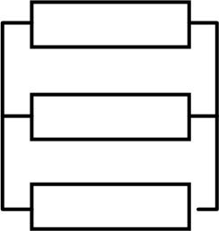For parallel circuits

1/RI + /R2 + /R3 = Total resistance

For Series circuit

RI + R2 + R3 = Total resistance 

When a light bulb is switched on, why the filament reaches a constant temperature?

* The power dissipated in the filament becomes equal to the rate of heat radiated by it.

Note: Color is linked to radiation.

* 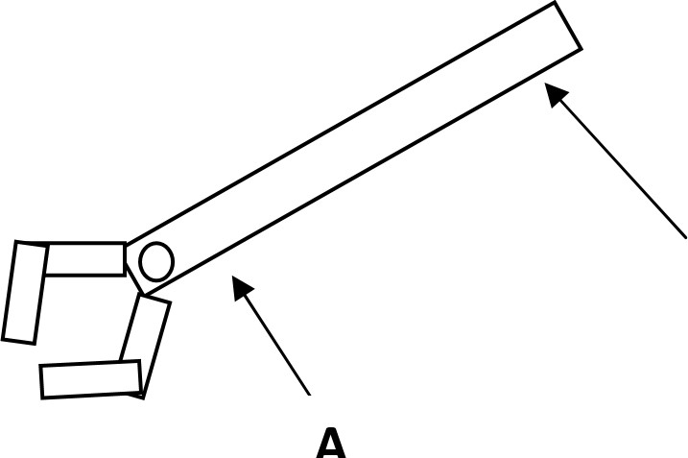Black is good absorber & emitter of heat.

Why better to push at B than A?

* The turning effect produced when force is applied at B is greater.

(Turning effect = Force x Distance)

Effect of applying force on a rusty bolt/nut.

 It will change the shape of edges of nut.

* Heat will be produced because of friction; it might also break.

**Light:**

Why ray not change direction at B? The ray is perpendicular to the boundary. 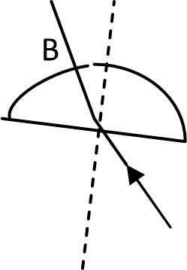

* In a glass, speed of blue light is slower than speed of red light because Blue light has shorter wavelength but same frequency.
* But in vacuum, the speed is the same.
* Image produced by a magnifying glass: Virtual, Upright, Magnified
* 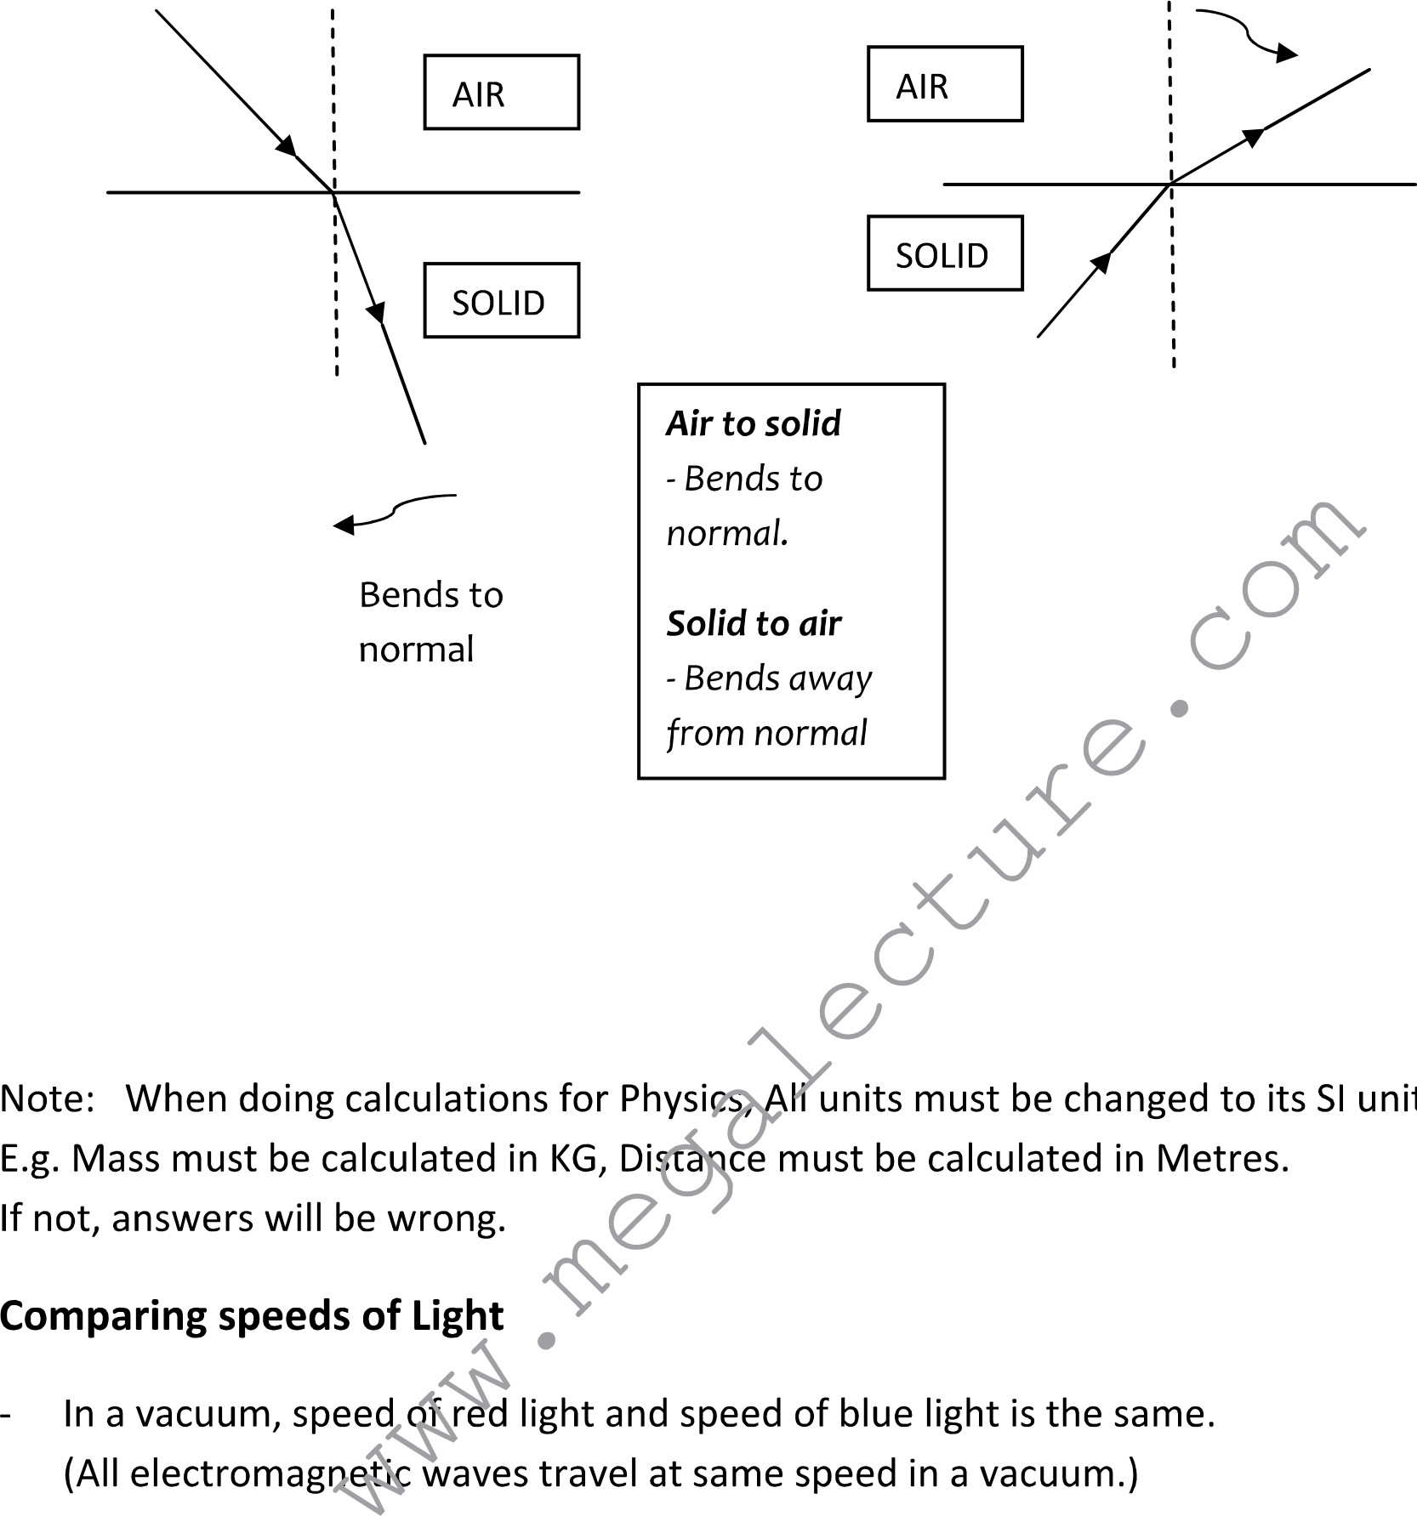







Physics laboratory safety precautions / rules:

* Live wires should not be touched.
* Hot Objects should not be touched with barren hands instead of that gloves should be used the most common process is heating of water in thermodynamic experiments.
* Circuit connections should be checked and approved by the teacher and then only the circuit should be switched ON.
* While changing components of the circuit the power should be switched so that one should not experience electric shocks.
* Safety spectacles, gloves and other safety components should be used while handling experiments.
* While handling a mercury thermometer one should take of the mercury spills.
* No other laboratory instruments should be touched or handled which is not involved in the course of experiments.

To produce more accurate or reliable results:

* Repeat experiment, to calculate average reading.
* Avoiding parallax error, look perpendicular to the ruler.
* If accuracy in measurement was asked, check for zero error.

Improvements that could be done to the experiment (temp. cooling):

* Same initial temperature.
* Same volume of water.
* Same shape of beaker.
* Beakers of same surface.
* Same room temperature.
* Stirring the water in the beakers.
* Same time intervals.
* Same surface area. (Unless given different containers)
* Adding water or cooling effect at regular intervals.

Heat loss could be reduced by:

* Insulation of beaker.
* Covering beaker with a lid.

For 2 values to be directly proportional,

* The graph of the values must be a straight line from the origin.

As value 1 increase, value 2 increases.

For images produced from lenses on screens, precautions taken:

* Use of a darkened room for the experiment.
* Avoiding parallax error in measurement and look perpendicular to the ruler.
* Object and lens at the same height from bench.
* Object/lens/screen is perpendicular to the bench.

To draw an image created from lens:

* Inverted from the original object.
* Sides are multiplied by the magnification.

*If values have difference by 0.1 or 0.01, that is the limit of experimental accuracy, so answers are about the same.

For spring extension experiment, variables that should be constant in the experiment:

* Number of coils.
* Diameter of spring.
* Selection of loads.
* Mass of spring

**Precautions:**

* Units ( e.g. voltage is V etc. ) cause the units hold 1 mark of the question
* The rest are calculations and measurements
* Use a sharp pencil when drawing graphs cause you may lose marks for the thickness of the lines
* Be so accurate in measuring angles

To produce more accurate or reliable results:

* Repeat experiment, to calculate average reading.
* Avoiding parallax error, look perpendicular to the ruler.
* If accuracy in measurement was asked, check for zero error.
* Same initial temperature.
* Same volume of water.
* Same shape of beaker.
* Beakers of same surface.
* Same room temperature.
* Stirring the beakers.
* Same time interval.
* Same surface area (unless given different containers).
* Adding cooling water at regular intervals.

Reduce **Heat Loss** by:

* Insulation of beaker.
* Covering beaker with a lid.

For two values to be directly proportional,

* The graph of the values must be a straight line from the origin.
* As value 1 increase, value 2 increases.

For images produced from lenses on screens, precautions taken:

* Use of a darkened room for the experiment.
* Avoiding parallax error in measurement and look perpendicular to the ruler.
* Object and lens at the same height from bench.
* Object/lens/screen is perpendicular to the bench.

To draw an image created from lens:

* Inverted from the original object.
* Sides are multiplied by the magnification.

*If values have difference by 0.1 or 0.01, that is the limit of experimental accuracy, so answers are about the same.

For spring extension experiment, variables that should be constant in the experiment:

* Number of coils.
* Diameter of spring.
* Selection of loads.
* Mass of spring.

for improving the accuracy of the results (for experiments):

Minimizing heating effect of a current:

* Lower current
* Increase voltage
* Add a lamp
* Increase resistance of a resistor

Sources of error in calculating circumference by string method:

* Parallax
* Diagonal winding
* Thickness of string

Improvement made to calculating circumference by string method

* Avoid parallax error
* Repeats and average
* Thinner string

Drawing graphs:

• Label axis

• Choose a proper scale

• Well-judged best fit line

• Thin and neat lines

Measuring the gradient:

• Draw a triangle on graph

• Use clear lines

• Triangle must be larger than half the line